**Statement vs PreparedStatement**

**Using Statement**

package p1;

import java.sql.Connection;

import java.sql.DriverManager;

import java.sql.SQLException;

import java.sql.Statement;

import java.util.Scanner;

public class Insert {

public static void main(String[] args) throws ClassNotFoundException, SQLException{

Scanner sc = new Scanner(System.in);

Class.forName("oracle.jdbc.driver.OracleDriver");

Connection con = DriverManager.getConnection("jdbc:oracle:thin:@localhost:1521:xe", "system", "manager");

Statement st = con.createStatement();

int rno, fees, count;

String name, course, q;

char choice;

do{

System.out.print("Enter Rno: ");

rno = sc.nextInt();

sc.nextLine();

System.out.print("Enter Name: ");

name = sc.nextLine();

System.out.print("Enter Course: ");

course = sc.nextLine();

System.out.print("Enter Fees: ");

fees = sc.nextInt();

q = "insert into student values("+rno+", '"+name+"', '"+course+"', "+fees+")";

count = st.executeUpdate(q);

System.out.println(count+" row(s) inserted");

System.out.print("Press 'y' to continue: ");

choice = sc.next().charAt(0);

}while(choice=='y' || choice=='Y');

con.close();

}

}

**Using PreparedStatement**:

package p1;

import java.sql.Connection;

import java.sql.DriverManager;

import java.sql.SQLException;

import java.util.Scanner;

import java.sql.PreparedStatement;

public class Insert {

public static void main(String[] args) throws ClassNotFoundException, SQLException{

Scanner sc = new Scanner(System.in);

Class.forName("oracle.jdbc.driver.OracleDriver");

Connection con = DriverManager.getConnection("jdbc:oracle:thin:@localhost:1521:xe", "system", "manager");

PreparedStatement pst = con.prepareStatement("insert into student values(?,?,?,?)");

int rno, fees, count;

String name, course;

char choice;

do{

System.out.print("Enter Rno: ");

rno = sc.nextInt();

sc.nextLine();

System.out.print("Enter Name: ");

name = sc.nextLine();

System.out.print("Enter Course: ");

course = sc.nextLine();

System.out.print("Enter Fees: ");

fees = sc.nextInt();

pst.setInt(1, rno);

pst.setString(2, name);

pst.setString(3, course);

pst.setInt(4, fees);

count = pst.executeUpdate();

System.out.println(count+" row(s) inserted");

System.out.print("Press 'y' to continue: ");

choice = sc.next().charAt(0);

}while(choice=='y' || choice=='Y');

con.close();

}

}

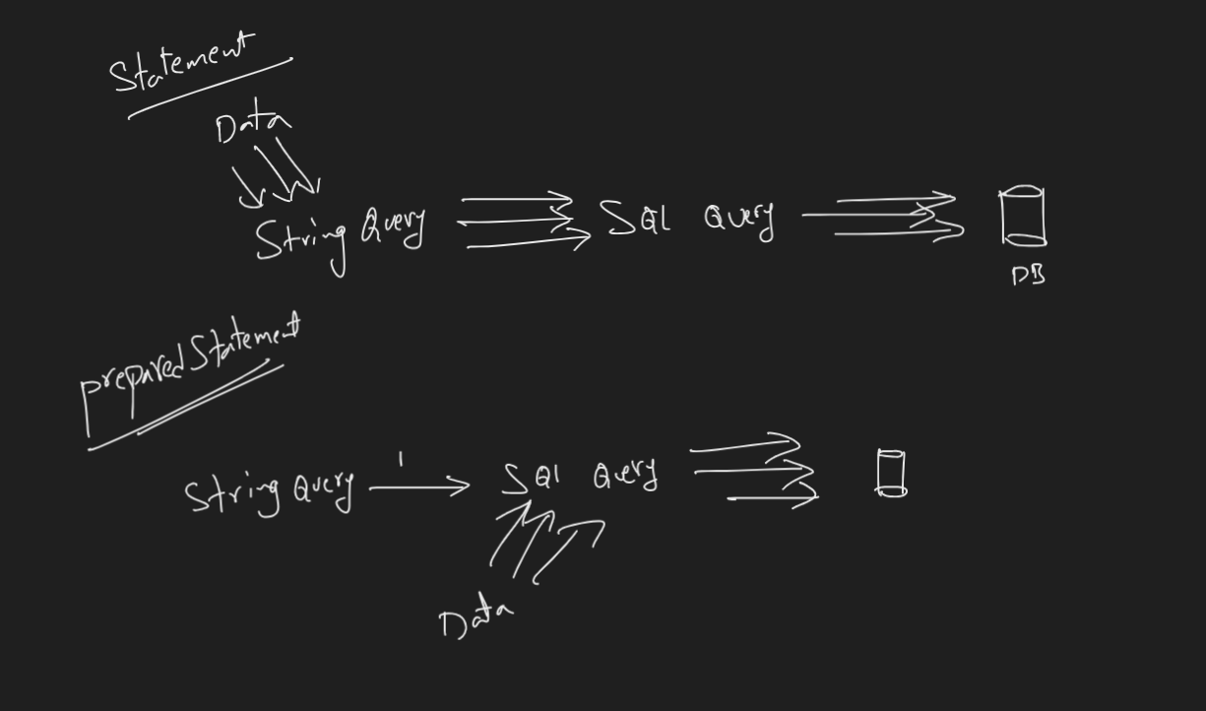

PreparedStatement Example 2:

package p1;

import java.sql.Connection;

import java.sql.DriverManager;

import java.sql.PreparedStatement;

import java.sql.ResultSet;

import java.util.Scanner;

public class Select {

public static void main(String[] args)throws Exception{

Scanner sc = new Scanner(System.in);

Class.forName("oracle.jdbc.driver.OracleDriver");

Connection con = DriverManager.getConnection("jdbc:oracle:thin:@localhost:1521:xe", "system", "manager");

PreparedStatement pst = con.prepareStatement("select rno, name, fees from student where course=? order by rno");

char ch = 'y';

while(ch=='y' || ch=='Y'){

System.out.print("\nEnter Course: ");

String course = sc.nextLine();

pst.setString(1, course);

ResultSet rs = pst.executeQuery();

System.out.println("RNO\tNAME\tFEES");

System.out.println("--------------------------------------------------");

while(rs.next()){

System.out.println(rs.getInt(1)+"\t"+rs.getString(2)+"\t"+rs.getInt(3));

}

System.out.print("Press 'y' to Continue: ");

ch = sc.nextLine().charAt(0);

}

}

}